

TCP2201

Object-Oriented Analysis and Design

TC02

GROUP ASSIGNMENT

Lecturer:

Lee Kian Chin

Project Name:

World War 4.0

Group Members:

|  |  |  |  |
| --- | --- | --- | --- |
|  |  |  |  |
| Nicholas Tan Yu Zhe | 1142701655 | nicholas.290696@gmail.com | 0167768182 |
| Choo Jia Sheng | 1142700814 | jason952002@gmail.com | 01110705798 |
| Wong Zi Xiang | 1142701102 | wongzx96@gmail.com | 01116906368 |
| Nicolas Raj a/l Paul Durai | 1142700982 | me@nicolasraj.com | 0107669780 |
| Muhammad Hisyam bin Bujang | 1142701234 | flundut@gmail.com | 0128869204 |

**Instructions**

1. Compile the file by using the following code:

javac MVCGame.java

1. Run the game by using the following code:

java MVCGame

**User Documentation**

1. Select between New Game, Load Game and Exit Game.

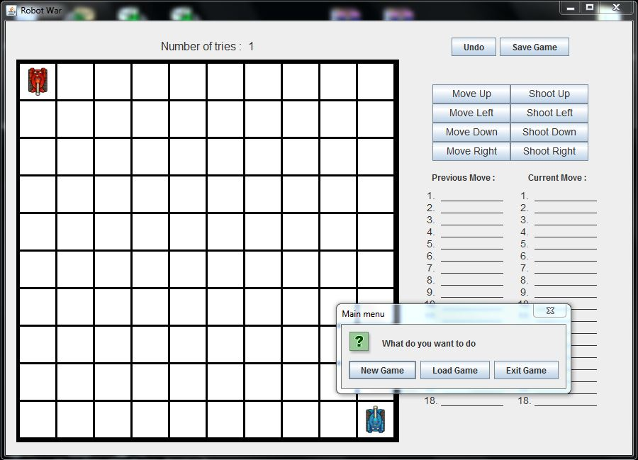

2. If Load Game is selected the program continues from the load file.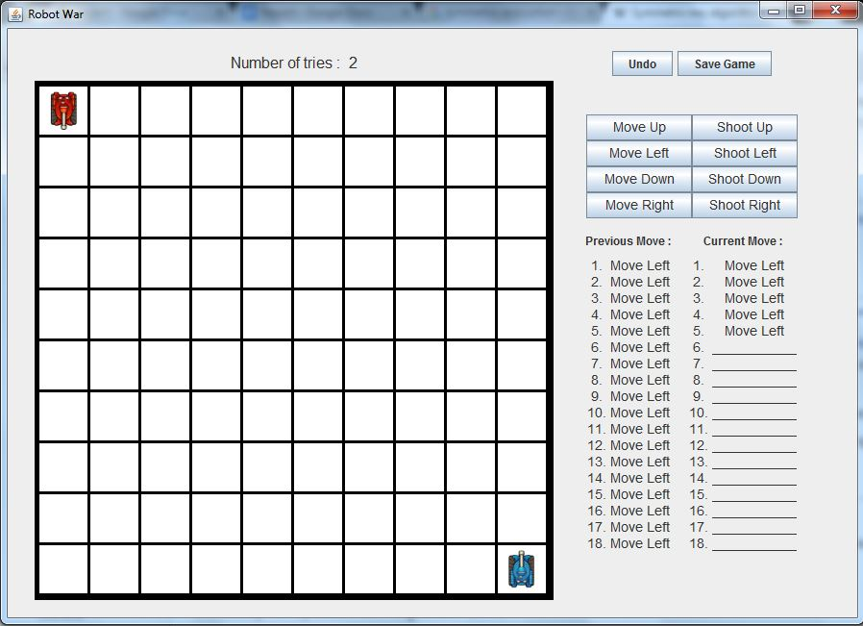

3. If New Game is selected you must choose 18 sequences that you wish to be executed by your tank to destroy the AI tank.

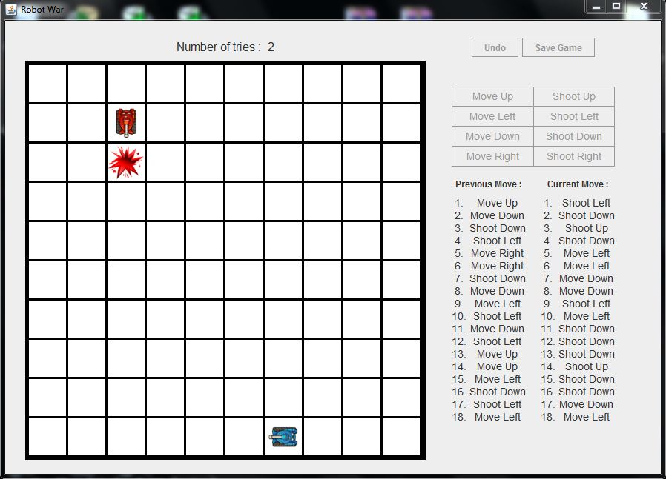

4. You can undo your moves as many times as you want.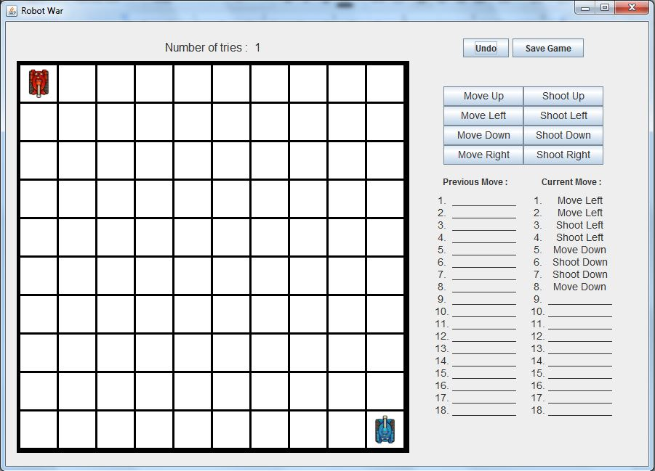

5. If you fail to to destroy the tank, you can try again for 9 times.

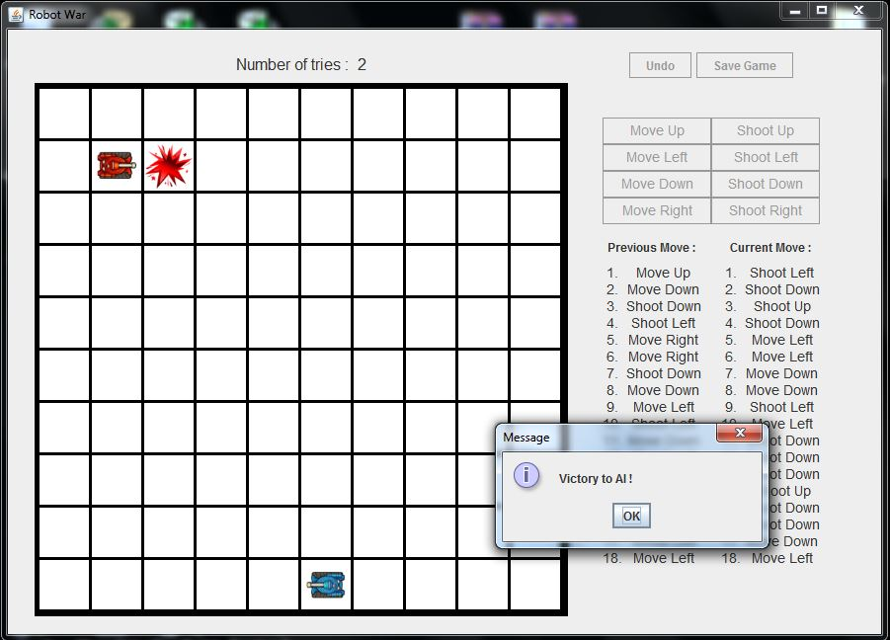

6. If you manage to destroy the tank a victory message is displayed.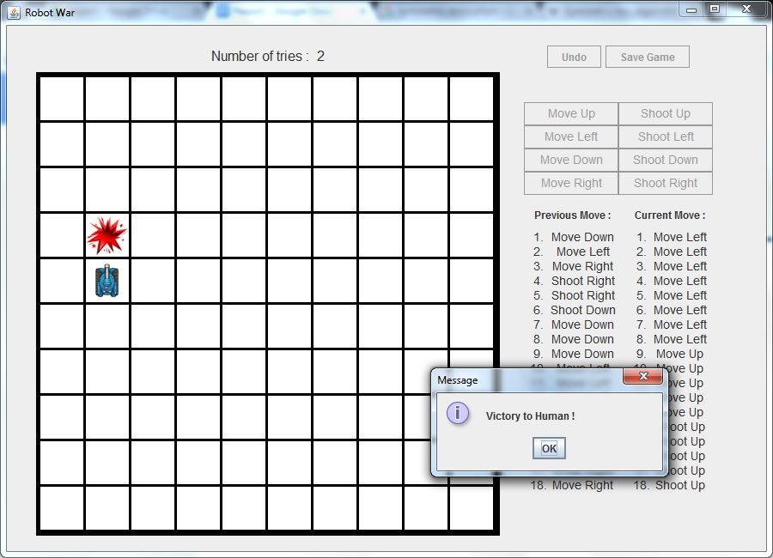

7. If you still failed after 10 tries a game over message is displayed.

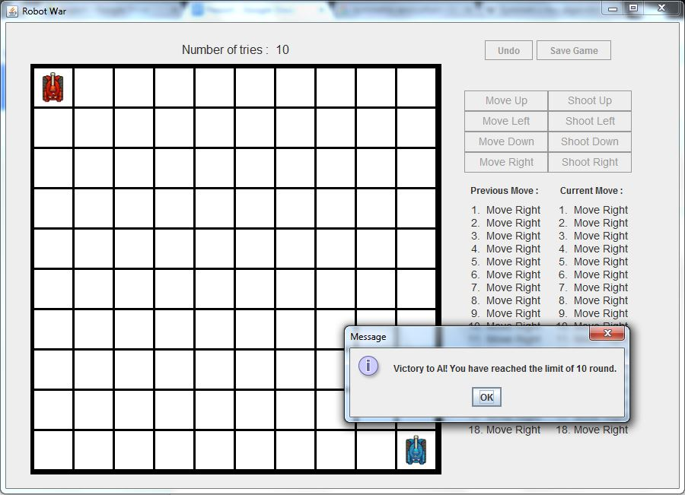

8. After winning or after 10 failed tries an option dialog pops up.

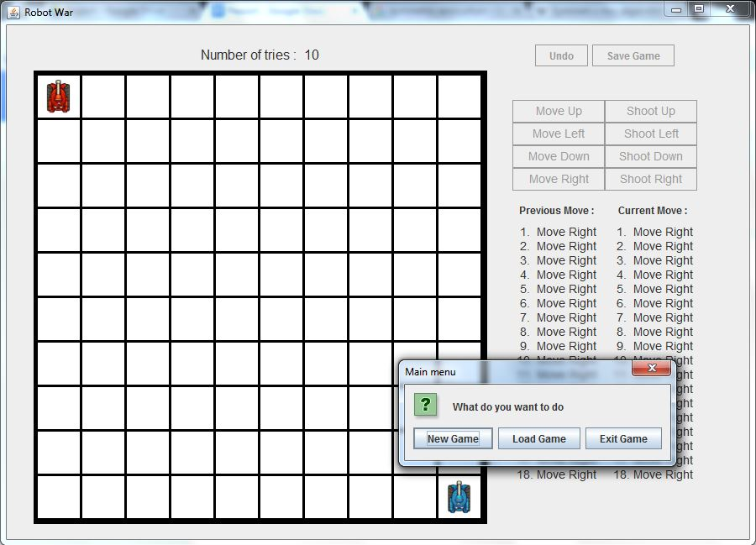

9. If you select save game, the program will override the current load game with the new save.

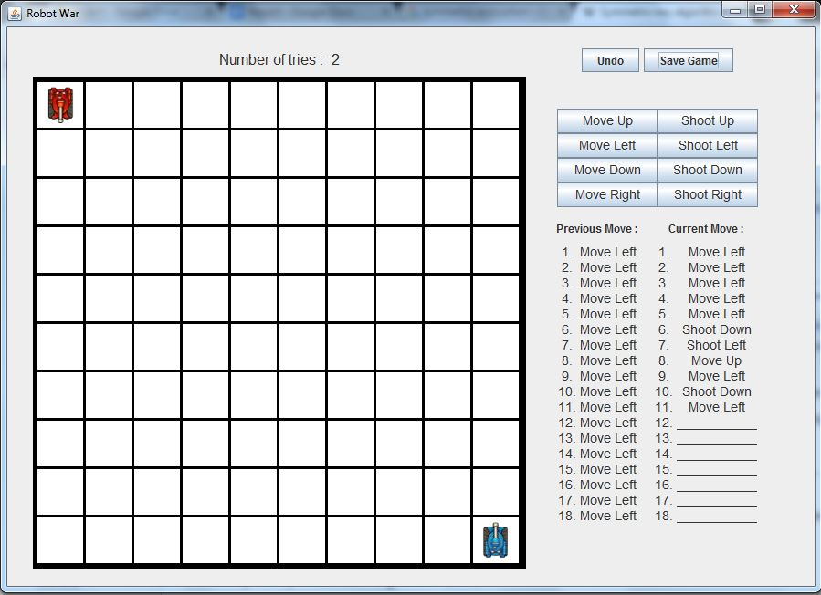

**Use Case Diagram**

Copy of Copy of Use Case Diagram.png

**Class Diagram**



**Sequence Diagram**

**Add Sequence**

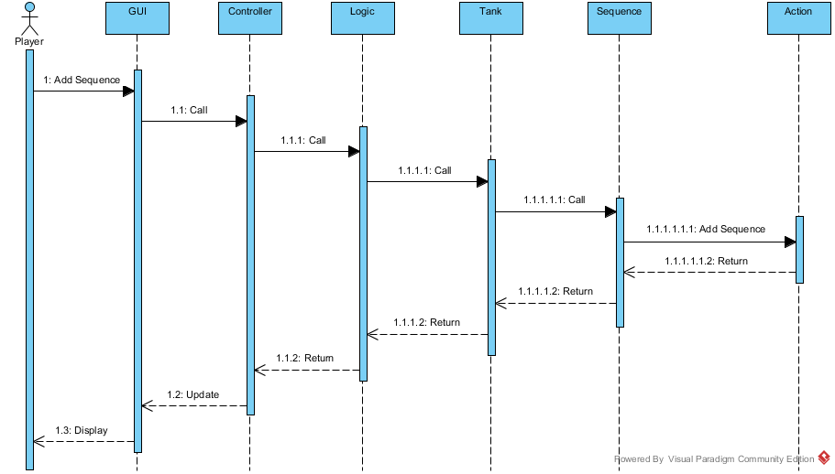

**Ai Random Sequence**

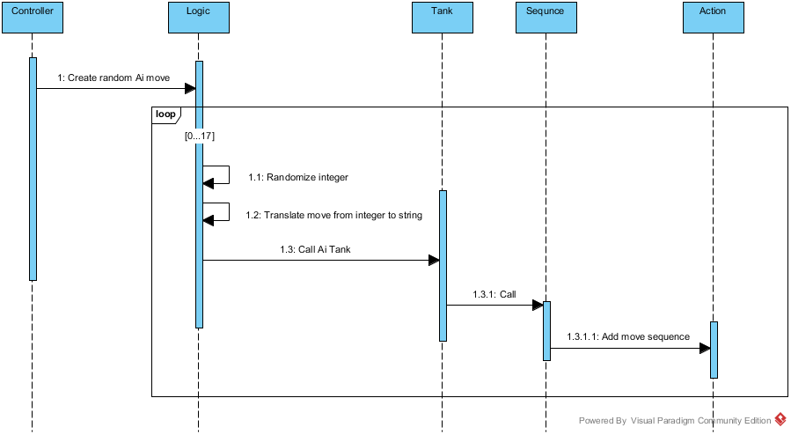

**Execute Sequence**

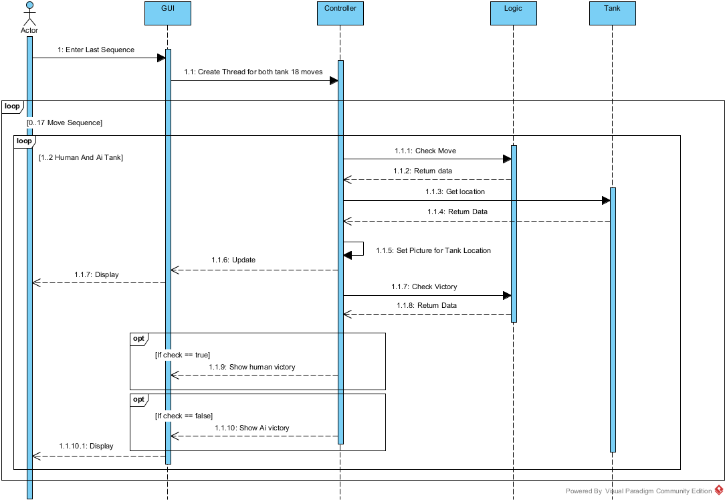

**Load**

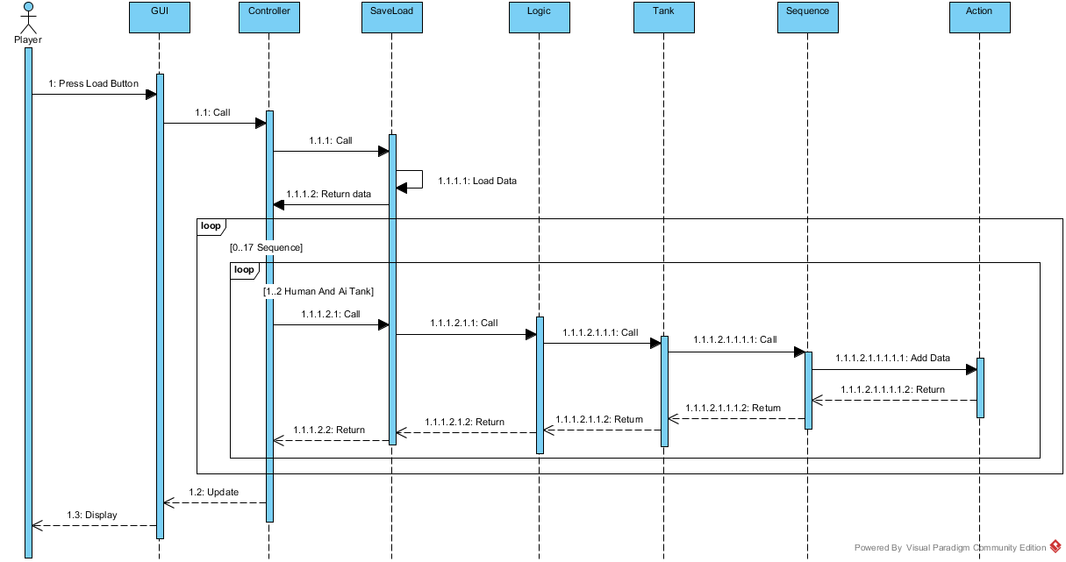

**New Game**

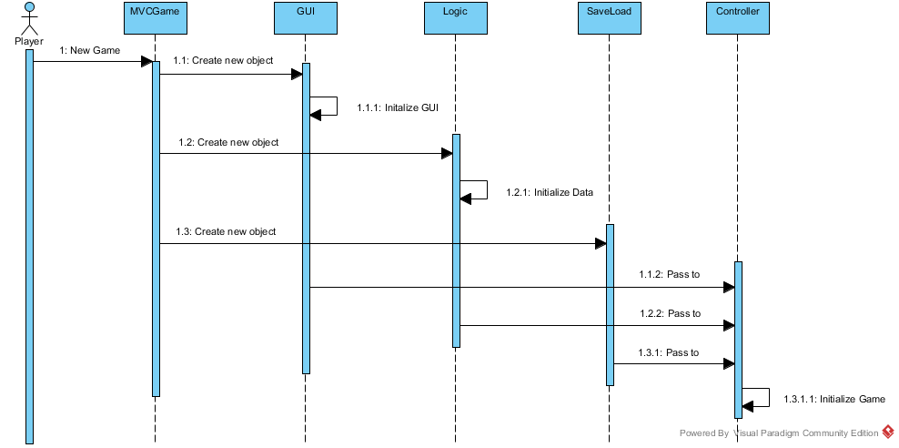

**Save**

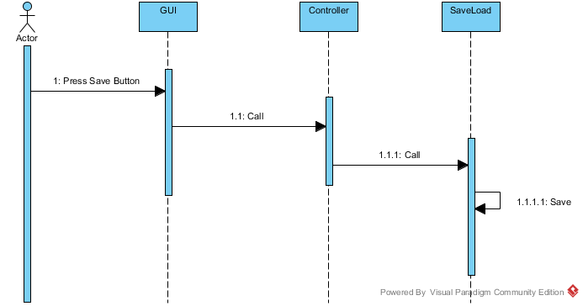

**Undo Sequence**

